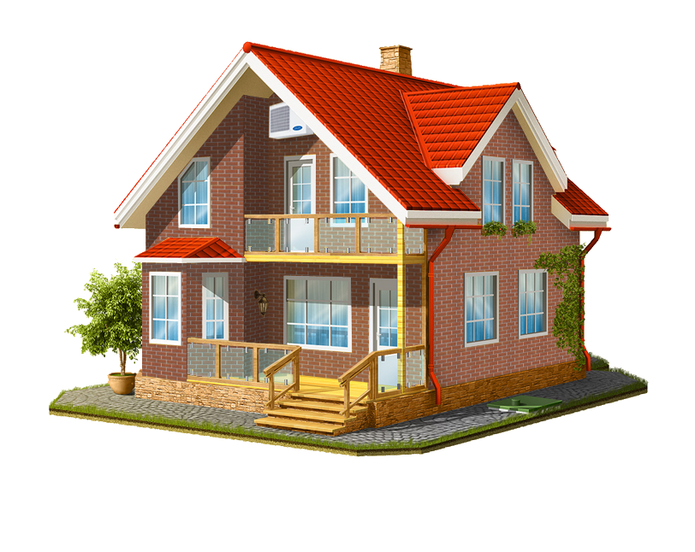

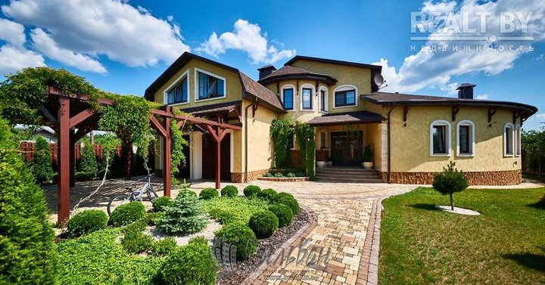

Ағылшын тілінен жаттығулары:

1.

My house is very important for me because I relax there and I can hide there from rain and snow. In my house there are six rooms: two bedrooms, a kitchen, a bathroom, a living room and a toilet. I spend most of my time in my room because I have to be alone for some time to do my homework, relax or read a book on my own. Near my house there is a wonderful but not very big garden where my parents usually grow something. I like my house because I'm already used to it and it's very beautiful. My family have guests nearly every day so we have to clean it every week. Anyway there is no other place I would prefer to live.

2. fill the gaps

My ……. is very important for me because I relax there and I can hide there from rain and snow. In my house there are six rooms: two ………, a kitchen, a bathroom, ………..and a toilet. I spend most of my time in my room because I have to be alone for some time to do my homework, relax or read a book on my own. Near my …….. there is a wonderful but not very big ………. where my parents usually grow potatoes. I like my house because I'm already used to it and it's very beautiful. My family have guests nearly every day so we have to clean it every week. Anyway there is no other place I would prefer to live.

Find out the words

k,n,e,h,c,t,i. …………………….

e,m,h,o. …………………….

l,g,n,i,v,i, m,o,r,o. …………………….

t,i,o,l,t,e. …………………….

a,g,r,d,n,e. …………………….

b,l,a,c,o,n,y. …………………….

e,d,b, m,r,o,o …………………….

b,t,h,a, o,o,r,m …………………….

Find out the words

k,n,e,h,c,t,i. …………………….

e,m,h,o. …………………….

l,g,n,i,v,i, m,o,r,o. …………………….

t,i,o,l,t,e. …………………….

a,g,r,d,n,e. …………………….

b,l,a,c,o,n,y. …………………….

e,d,b, m,r,o,o …………………….

b,t,h,a, o,o,r,m …………………….

Find out the words

k,n,e,h,c,t,i. …………………….

e,m,h,o. …………………….

l,g,n,i,v,i, m,o,r,o. …………………….

t,i,o,l,t,e. …………………….

a,g,r,d,n,e. …………………….

b,l,a,c,o,n,y. …………………….

e,d,b, m,r,o,o …………………….

b,t,h,a, o,o,r,m …………………….

kitchen bathroom living room toilet bedroom house home window roof study balcony garden

in front of

behind

in the middle

on the left

on the right